Key Functionaries
President
Profile: Rev. Mother Anthonyamma Pyyreddy
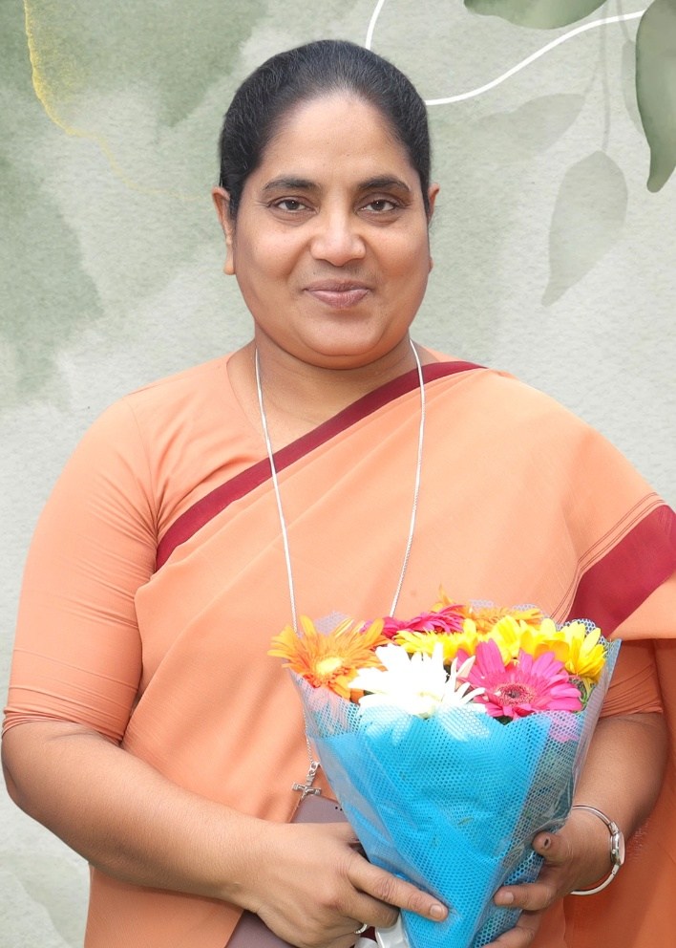
Superior General & President of Schools and Colleges
Rev. Mother Anthonyamma Pyyreddy is a visionary leader and a cornerstone of the Society of St. Anne (SSA). Since 2016, she has served with distinction as the Superior General, providing spiritual and administrative guidance to the congregation. In her dual role as the President of Schools and Colleges, Mother Anthonyamma has been instrumental in shaping the academic excellence and holistic development of our educational institutions.
With a deep-seated commitment to service and a forward-thinking approach to leadership, she has spearheaded numerous initiatives that blend traditional values with modern educational standards. Her tenure is marked by a profound dedication to empowering the youth through quality education and nurturing a compassionate, value-based environment for both students and faculty alike. Under her stewardship, the Society continues to expand its mission of transformative service, fostering a legacy of integrity, wisdom, and social responsibility.

Secretary
Profile of Excellence: Dr. Sr. Thumma Theresamma
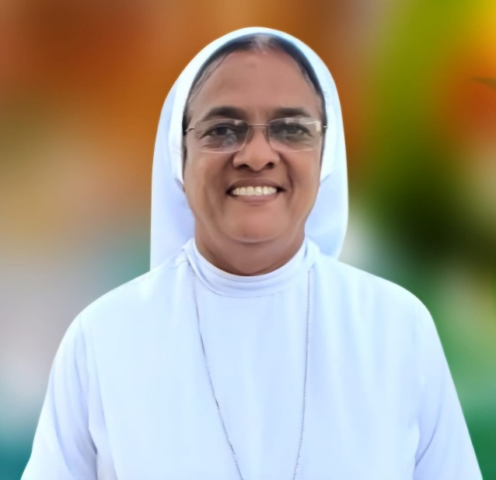
Dr. Sr. Thumma Theresamma is a distinguished academician and a visionary leader who currently serves as the Provincial Superior of the Guntur Province (CSSA). With a career spanning over three decades, she has become a cornerstone of nursing education and administrative excellence in India. Her academic journey is marked by extraordinary brilliance, beginning with her B.Sc. in Nursing from Osmania University, where she was an eight-time Gold Medalist and the prestigious recipient of the President’s Medal. She continued her streak of excellence as a Gold Medalist during her M.Sc. at RAK College of Nursing, Delhi University, eventually culminating her formal education with a Ph.D. from Sri Padmavathi Mahila University.
As a seasoned administrator, Dr. Sr. Theresamma has dedicated 30 years to shaping future healthcare professionals, serving notably as the Principal and Professor at St. Ann's College of Nursing for 20 years and Nava Chaitanya Nursing School for a decade. Beyond the classroom, her influence extends to university governance; she has been a vital member of the Senate and Board of Studies at Dr. N.T.R. University of Health Sciences since 2001. Her leadership within the Society of St. Anne has been equally impactful, having held high-ranking positions including Assistant Superior General and General Councilor before her current provincial appointment.
Recognized for her compassion and professional rigor, she has been honored with the Florence Nightingale Award, the Jewel of India Award, and the Best Teacher Award. Dr. Sr. Theresamma remains a symbol of dedicated service, blending spiritual leadership with academic mastery to advance the standards of nursing and community welfare.

Correspondent: Leadership Profile: Rev. Dr. Sr. Fatima Rani. P
Dr. Sr. Fatima Rani. P is an eminent academician, a dedicated social worker, and a visionary administrator who currently serves as the Correspondent of St. Ann’s Degree and PG College, Gorantla. With a profound academic background including a Ph.D. in English, M.Phil, and M.A. Litt., she has devoted over four decades to the mission of education and administrative leadership. Her extensive career is marked by nearly 40 years of service as a Principal across various levels—including English Medium Schools, Intermediate Colleges, and UG & PG Professional Colleges—where she has consistently fostered environments of academic rigor and holistic development.
Beyond her institutional roles, Dr. Sr. Fatima Rani has held significant leadership positions within the Society of St. Anne, serving two distinguished terms as the Provincial Superior of the Guntur Province from 2008 to 2016. Under her dynamic guidance as the Chairperson of IQAC, St. Ann’s College for Women, Gorantla, recently achieved a prestigious "A" Grade from NAAC in its first cycle (2024), a testament to her unwavering commitment to quality education and institutional excellence.
Her contributions have been widely recognized through numerous national and regional honors, including:
- The Indira Gandhi National Memorial Award (1995) for securing seven state ranks.
- The Rajiv Gandhi Award (2008) for Best Principal.
- NIRF Ranking Success (2017), placing the institution in the 151-200 band nationally.
- The Lady Legend Inspiration Award (2022) and the Best Social Worker Award (2024) for her tireless outreach and community service.
A true "Lady Legend" and an "Ideal Woman in Society," Dr. Sr. Fatima Rani continues to inspire the faculty and student body alike, blending compassionate social service with a relentless pursuit of academic distinction.
